**Homework 4**

By- Na Li, Yash Naik

In this assignment, Na Li implemented Perceptron Learning Algorithm(PLA) and Pocket Algorithm. Yash Naik implemented the Logistic Regression Algorithm and Linear Regression Algorithm.

**Part 1: Implementation**

**Perceptron Learning Algorithm**

This algorithm is implemented in Python. The data structure I used is a numpy matrix. I imported the first three columns(i.e, coordinates data) in matrix X, and the fourth column(i.e, the label) in matrix y. The epochs time we choose is 800. Since it takes a few time to complete all epochs, we imported tqdm to visualize the current progress.

The result is shown below:



**Pocket Algorithm**

This algorithm is similar to the Perceptron Learning Algorithm. The difference between them is that the pocket algorithm picks a random point at each echo, and updates the new point when it makes fewer mistakes. There is not too much challenge here, since we could reuse logic that was implemented in the Perceptron Learning Algorithm, and the difference is we need to compare the current weight with previous best_weight, and update it if needed. The data structure we used is still the numpy matrix. Firstly, we imported the first three columns in matrix X, and the fifth column(i.e, the label) in matrix y. The epochs time we choose is 7000. We also imported tqdm to help visualize the current progress.

The result is shown below:

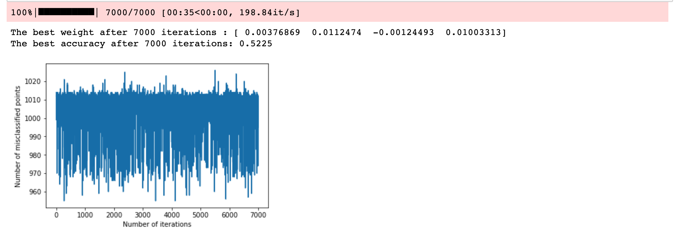

**Logistic Regression**

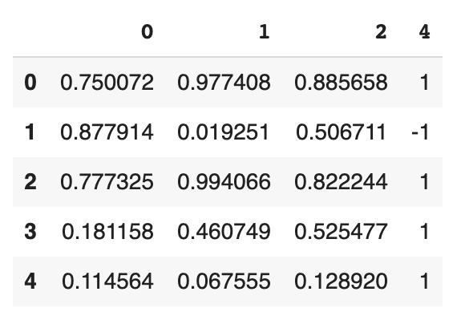

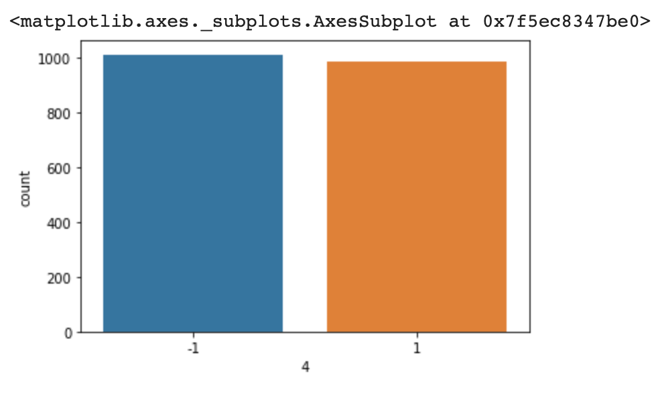

For this part of the assignment, I have implemented the Logistic regression algorithm in Python. I have used pandas dataframe as the initial data structure to load the classification data, because pandas makes data wrangling easier. Next, I converted the dataframe to a numpy array to get the final weights using the sigmoid function because numpy is very powerful in matrix computations.





**Linear Regression**

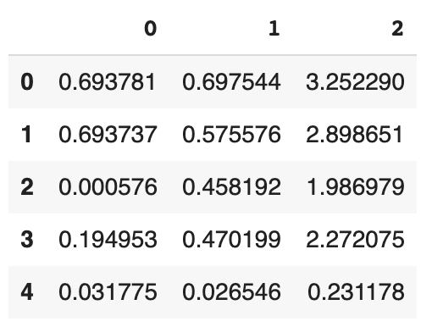

Implementing Linear Regression was by far the easiest part of this assignment. I have again used a pandas dataframe as the primary data structure as it makes it easier to deal with data. After the final iteration, the weights for the equation were-

